The official way to move the VirtualBox folder is to first export your virtual machines to an OVA file and then import the OVA file at the new location:

1. Click **File > Export Appliance**.  
   [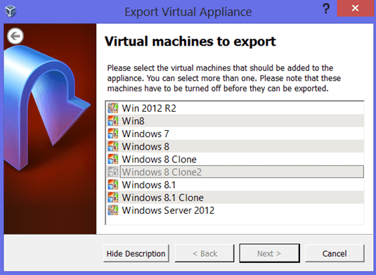](https://4sysops.com/wp-content/uploads/2013/08/Export-Virtual-Appliance.png)
2. While holding the CTRL key, click the virtual machines you want to export.
3. Choose the **location of the OVA file**, click Next, and then export.
4. Change the **Default Machine Folder** under File > Preferences > General.  
   [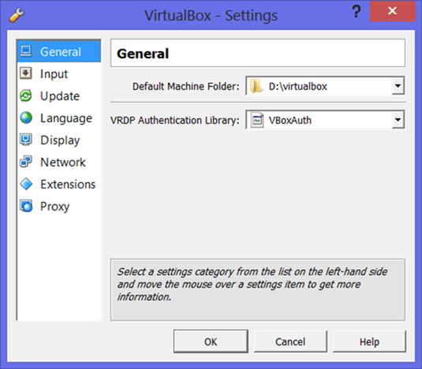](https://4sysops.com/wp-content/uploads/2013/08/Default-Machine-Folder.png)
5. Click **File >** **Important Appliance**, select the OVA file, and import.

The downside of this option is that the export and import of the OVA file is extremely slow and error prone