# Hardware requirements:

* One Linux Raspberry Pi with 2 NICs
* Two Switches
* Two Cliens on separate PCs

# Procedure:

## Part 1

Configure two PCs with IP addresses for different network class environments, e.g. one for 192.168.1.0/24 (Class C) and one for 172.16.0.0/16 (Class B).

**Optional:** After the PCs are set up connect them with a switch to show they do not communicate since they are in different networks. In Part 2 of this lab they will be connected via a router and communication will be enabled by the router.

1. Configure the first PC’s IP environment
   * With root authority:
     + router1@qaddebian1:~$ su
   * Configure the IP address to a Class B (172.16.33.1 – 172.16.33.253), e.g. 172.16.33.10
     + qaddebian1:/home/router1# ifconfig eth0 172.16.33.10
2. Configure second PC’s IP environment
   * Configure the IP address to a Class C (192.168.33.1 – 192.168.33.253), e.g. 192.168.33.10
     + qaddebian1:/home/router1# ifconfig eth0 192.168.33.10

**Optional:**

1. Connect the two PCs with a switch and test
2. Ping to verify the two PCs cannot communicate
   * From first PC
     + ping self: qaddebian1:/home/router1# ping 172.16.33.10
     + ping other: qaddebian1:/home/router1# ping 192.168.33.10
   * From second PC
     + ping self: qaddebian1:/home/router1# ping 192.168.33.10
     + ping other: qaddebian1:/home/router1# ping 172.16.33.10

## Part 2

Add the Pi router to the network and make necessary changes to the PC IP configurations. The PI router and the PCs will reconfigured to allow communications between the two disparate networks.

1. Configure the Pi router IP

* Change to root user: router1@qaddebian1:~$ su
* Configure the gateway for 172.16.33.0 network
  + - qaddebian1:/home/router1# ifconfig eth0 172.16.33.254
* Configure the gateway for 192.16.33.0 network
  + - qaddebian1:/home/router1# ifconfig eth1 192.168.33.254
* Enable the ip forward function in Linux (very important!)
  + - qaddebian1:/home/router1# echo 1 > /proc/sys/net/ipv4/ip_forward
* Use the *ifconfig* and *route* commands to verify
  + - qaddebian1:/home/router1# ifconfig
    - qaddebian1:/home/router1# route

1. Modify first PC’s IP
   * add default gateway for eth0 (very important!)
     + qaddebian1:/home/router1# route add default gw 172.16.33.254
   * use ***route*** command to verify the routing table
     + qaddebian1:/home/router1# route
2. Modify second PC’s IP
   * add default gateway for eth0 (very important!)
     + qaddebian1:/home/router1# route add default gw 192.168.33.254
   * use ***route*** command to verify the routing table
     + qaddebian1:/home/router1# route
3. Physically connect the system together
   * The Debian router will be inserted between the two VMs, see Figure 1
4. Test connections
5. Ping to verify the two VMs cannot communicate
   * ping self, for example (just for the fun of it)
     + qaddebian1:/home/router1# ping 172.16.33.10
   * ping the gateway
     + qaddebian1:/home/router1# ping 172.16.33.254
   * ping other
     + ***qaddebian1:/home/router1# ping 192.168.33.10***

# Trouble shooting:

* Can’t change IP:
* switch to ***root*** user
* use ***ifconfig*** to show the basic information
* Can’t ping gateway: make sure to change default gateway after configuring the IP  
  Use:
* qaddebian1:/home/router1# route add default gw 172.16.33.254 ***- or -***
* qaddebian1:/home/router1# route add default gw 192.168.33.254
* Can’t ping other network: make sure to open the Linux IP forward function Try:
  + qaddebian1:/home/router1# echo 1 > /proc/sys/net/ipv4/ip_forward

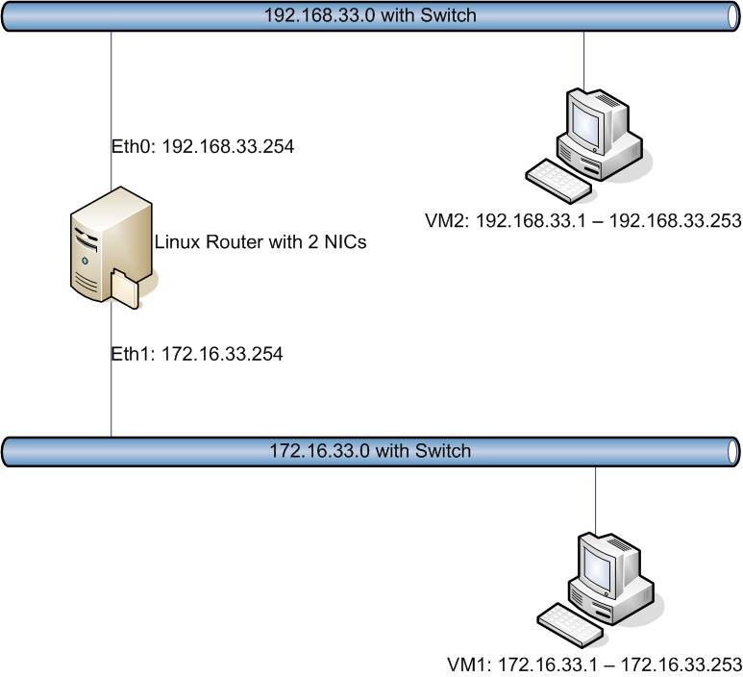

Figure 1: Completed network for userid 33.