Man-In-The-Middle attack on switched Ethernet
This lab exercise demonstrates how to become Man-In-The-Middle on a switched Ethernet.
Environment:
Your are the attacker who tries to intercept a victim’s traffic. The victim constantly contacts a web server that computes a simple mathematical function for the victim. The attacker and the victim are located on the same switched Ethernet. The server is located outside your LAN. Assume that the attacker knows the IP address of the victim.
Attacking Tools Provided:
- wireshark
  - This is a well-known network protocol analyzer.
- sendarp.exe
  - This program sends an arbitrary ARP reply message. You need tool to poison ARP cache. Please check reference section for the format of Ethernet frame and ARP reply message.
- mim.exe
  - This program forwards intercepted traffic to the victim and the router. It also dumps the intercepted traffic to “victim.captured” file that can be viewed using wireshark.
Goal:
The goal of this lab is to intercept the traffic between the victim and the server while not disrupting the service between them. After a few successful HTTP sessions have been intercepted, you should be able to guess the mathematical function the web server computes for the victim.
Reference:
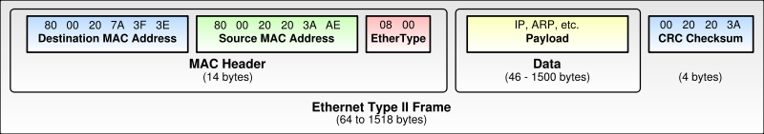
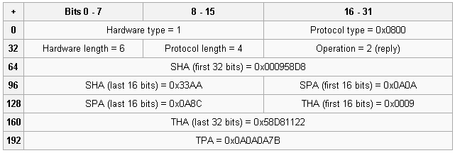
An ARP reply example

