In this exercise you will use Visual Basic .NET to create a feedback form*. Note: that when you enter a starting tag, VS.NET automatically supplies the proper ending tag. Ensure that the data you enter goes between the starting and ending tags.*

1. Type the command in command line: **net use**, to check whether there is a **V** drive on you lab machine. If there is not, type the following command: **net use v: \\coit-ts2003.uncc.edu\<yourusername>**. Make sure you insert the space between the v: and \\ in the previous command. Then it will ask you for your user name and password. Just input them. If it succeeds, you can go to next step.
2. Start Microsoft Visual Studio 2005. If it is the first time you use it, select general develop sitting environment. Click **New Website**. In the New Website window**,** select **ASP.NET Web Service** in the Templates pane. Replace **H:\My Documents\Visual Studio 2005\WebSites\WebSite1** with **V:\Form1** in the Location text box. Click **OK**. The blank web form should appear.
3. In the Solution Explorer right click **V:\Form1\**. Click **New Folder** and rename it as **Form1**. Then right click this new folder **Form1** and click **Add New Item.** Then select **HTML Page** in templates. In the Name text box enter **SurveyForm.html** then click **Add**.
4. Change from **Source** to **Design** on the bottom of design window. Change your cursor to be **center aligned** (use the menu for centering on the top of the page). From the Toolbox (click icon on the left border) drag a **Table** onto the layout grid. While the Table is selected, change the **Border** value to **1** in the **Properties** window (on the bottom right). Then adjust it to a size you prefer. The default number for both row and column are 3. According to this work, you need to change it to **5 rows and 2 columns**. In order to do this, you can change from **Design** to **Source**, and find this section of code as shown below:

<tr>

<td>

</td>

<td>

</td>

<td>

</td>

</tr>

<tr>

<td>

</td>

<td>

</td>

<td>

</td>

</tr>

<tr>

<td>

</td>

<td>

</td>

<td>

</td>

</tr>

Replace this section of code with code as shown below: (by doing this, you actually change the original 3x3 table to a table suitable for this work. Please understand the reason why we should split table like this.)

<tr>

<td colspan="2">

</td>

</tr>

<tr>

<td>

</td>

<td>

</td>

</tr>

<tr>

<td>

</td>

<td>

</td>

</tr>

<tr>

<td>

</td>

<td>

</td>

</tr>

<tr>

<td colspan="2">

</td>

</tr>

1. 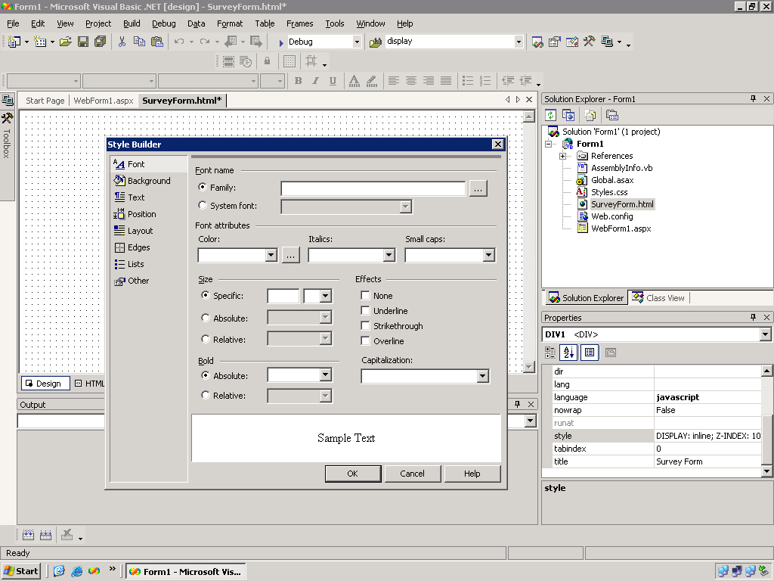Change back from **Source** to **Design**. Click your cursor to the first row. In the Properties pane click **Style** then click the ellipsis button on the right side of the text box. The Style Builder window appears as shown below:



1. Click the ellipsis button to the right of the Family text box. Under Installed Fonts scroll down until “Verdana” appears. Click **Verdana** then click the right arrow to move “Verdana” into the Selected Fonts area. Click **OK**.
2. Click the drop-down button to the right of the Color text box. Select **Blue**.
3. In the Size section, ensure that Specific is selected. In the text box to the right enter **24**. Note that “pt” should appear automatically to the right. If it does not, click the drop-down button then click **pt**.
4. In the Bold section ensure that Absolute is selected. Click the drop-down arrow to the right of the text box and click **Bold**. Click **OK**.
5. Type in ***YourName’s* Survey Form** in the first row. (Be sure to replace ***YourName’s*** with your name!) You will see it in a style you have defined.
6. Type in **Your Name** in the first column of the second row. Type in **Age Range** in the first column of the third row. They are both in default style. Type in **Your Favorite Color** in the first column of the forth row. Change all these texts to be **left aligned** (use menu on the top of the page).
7. From the Toolbox drag an **Input (text)** control to the second column of the second row. Change it to be **left aligned**.
8. From the Toolbox drag a **Select** control to the second column of the third row. Change it to be **left aligned**. Right click the **Select** control then click **Properties**. The Property Pages window appears as shown below (just a little bit different):

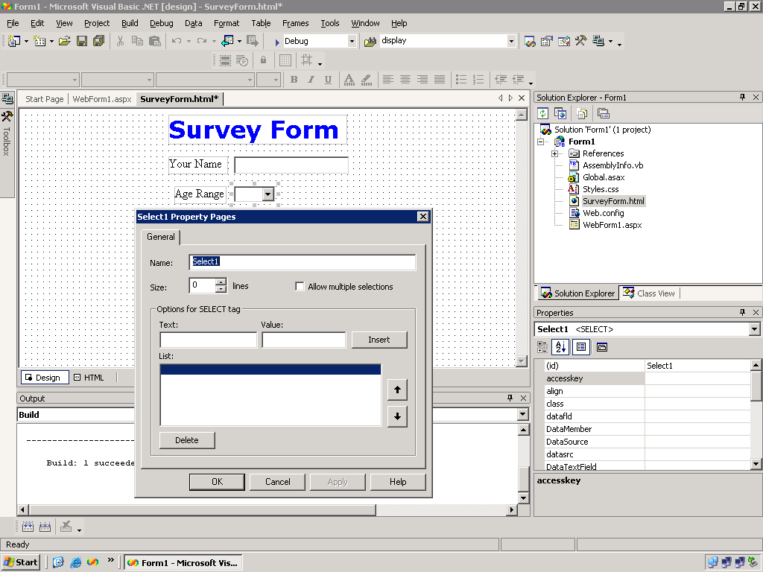

1. In the **Options for SELECT tag** section in the **Text** text box enter **11-20**. Press **Tab**. In the Value text box enter **1** then click **Insert**. Note that these values appear in the List section. This corresponds to one menu choice in the Dropdown control. Repeat these steps to enter **21-30** (Value = **2**), **31-40** (Value = **3**), **41-50** (Value = **4**), and **51-60** (Value = **5**). Ensure the value in the **Size** text box is **0**. Click **OK**.
2. From the Toolbox drag an **Input (Radio)** control to the second column of the forth row.
3. Type in the word **Red** right next to this radio button (or you can put a space between them). Press the button “Enter” on your keyboard to change a line.
4. Repeat steps 15 and 16 to add three more radio buttons and texts for **Blue**, **Yellow**, and **Green** to the form. Change them to be **left aligned**.
5. From the Toolbox drag an **Input (Submit)** button to the last row. With the Submit button control selected click the **value** property in the Properties window and change the value to **Submit Your Survey**.
6. **Save All** then **Build Solution**. Right click on the grid then click **View in Browser**. Your form should look something like this:

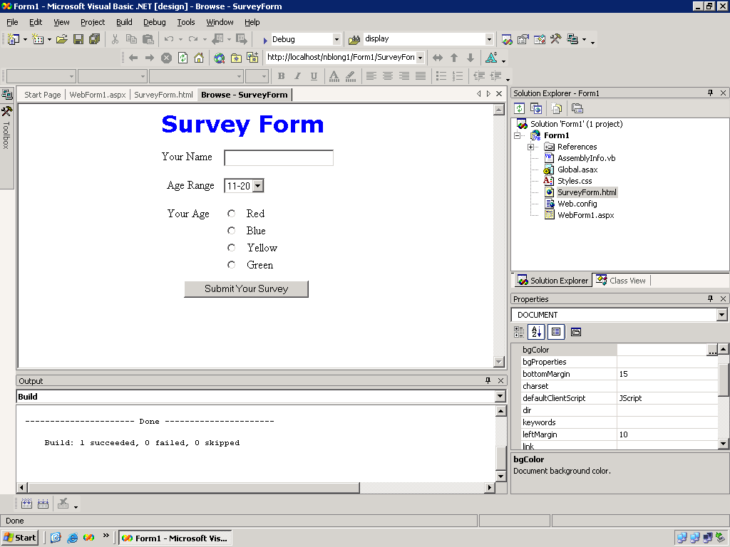

1. Click **WebSite**. Click **Copy Web Site.** Click **Connect.** Select **FTP Site**. Type in Server Name as *coit-ts2003.uncc.edu*. (make sure you enter it correctly)Unclick the **Anonymous Login** and input your username and password. Click **Open**. If windows show you block message, just **unblock** it. Select the folder **Form1** which you have created today. Click **copy…to** button in the middle.
2. Launch a browser. In the Address text box enter:

http://coit-ts2003.uncc.edu/*<username>*/Form1/SurveyForm.html

Try the controls then close the browser. Close Visual Studio.