In this exercise you will create an ASP.NET page that uses HTML server controls to dynamically change the contents of the page.

1. Type the command in command line: **net use**, to check whether there is a **V** drive on you lab machine. If there is not, type the following command: **net use v: \\coit-ts2003.uncc.edu\<yourusername>**. Make sure you insert the space between the v: and \\ in the previous command. Then it will ask you for your user name and password. Just input them. If it succeeds, you can go to next step. If there is a v: drive ensure it is connected to your drive. If not disconnect with **net use v: /d** and then attach to your drive. You may use a thumb drive to keep your data instead of the network v: drive.
2. Start **Visual Studio 2005**.
3. In *Recent Projects* click Create: *Web Site…* to open the *New Web S*ite window.
4. In the New Web Site pane: In the Templates pane, click the **ASP.NET Web Site** icon. In the *Location:* line click on Browse… and select your v: drive (or your thumb drive letter is you have a thumb drive connected) and add \**Music** to the end of the name, e.g. v:\music. Ensure *Language:* is set to Visual Basic. Click **OK** to create the solution, project, and default files. Note that an aspx file named Default.aspx along with a folder App_Data and another file web.config is created automatically for you.
5. In the Solution Explorer right click **V:\Music\**. Click **New Folder** and rename it as **Music**. Then **right click** this new folder **Music** and click **Add New Item**. Then select **Web Form** in template. In the Name text box enter **WebForm1.aspx** then click **Add**.
6. Ensure **WebForm1.aspx** is selected and is in **design view**. Expand the *Standard* element in the Toolbox then drag a **Label** control from the Toolbox and drop it on the grid. Right-click the background outside of this Label control then click **Run As Server Control**. Right click the Label and select *Style…*. The **Style Builder** panel should open.  
     
   Select Font from the left selection list. Change the Font name Family to **Trebuchet MS** by clicking on the … and make the selection from the list. Be sure to click the >> to get it in the *Selected fonts:* box. Click OK. In *Size* select Specific and enter 15 pt. Next select Position from the left hand selection list and set Position mode: to Absolutely position. Set Top: to 100, Left to 139, Height to 26, and Width to 365. Click OK.  
     
   With the Label control still selected, in the Properties window (lower left) change the *ID* property to **lblTitle** and delete the word **Label** in *Text*.
7. Next,Drag and drop a **Button** control from the toolbox to the grid. In the Properties window, change the *ID* property to **btnCD** and the *Text* to **CD**. Open the **Style Builder** (as above) and change the position to top: **140**, left: **138**, height: **27**, and width: **89**. Click **OK**.
8. Again, from the Toolbox, drag and drop a **Button** control to the grid. Do the same as the previous button, but make the ID **btnDVD** and the text to **DVD**. Open the Style Builder and change the position to top: **180**, left: **138**, height: **27**, and width: **89**. Click **OK**.
9. Drag and drop a **Label** control from the Toolbox to the grid. In the Properties window, change the ID property to **lblDVD**. With **Style Builder** change the Font Family to **‘Trebuchet MS’** and the Font Size to **12 pt**. Change the position to top: **140**, left: **235**, height: **210**, and width: **250**. Click **OK**.
10. Add the following text in the control, placing each item on a separate line: **Aladdin, Raising Helen, The Day After Tomorrow, Van Helsing, Shrek 2, Man on Fire** (do this by following the code below)   
    Note: you may change the name of the DVD listed if you like.   
    This is a little tricky. Switch to source and find this section of code:   
    <asp:Label ID="lblDVD" runat="server" Style="left: 235px; width: 250px; font-family: 'Trebuchet MS'; position: absolute; top: 140px; height: 210px" Text="Label"></asp:Label>  
      
    then add **all** the following code to the place which black arrow points.  
    <ul><li>Aladdin</li><br/><li>Raising Helen</li><br/><li>The Day After Tomorrow</li><br/><li>Van Helsing</li><br/><li>Shrek 2</li><br/><li>Man on Fire</li></ul>
11. Drag and drop the **Label** control from the HTML tab to the page. In the Properties window, change the ID property to **lblCD**. Click the **Style** Property and the **Style Builder** button. Change the Font Family to **‘Trebuchet MS’** and the Font Size to **12 pt**. Change the position to top: **140**, left: **500**, height: **210**, and width: **250**. Click **OK**.
12. Click inside the label you just created. Delete the default text within the Label control. Add the following text in the control, placing each item on a separate line: **Usher, Simple Plan, Nelly, George Strait, Tim McGraw, Maroon 5**. Then select all of the items and click the Bullets icon on the Formatting toolbar to change the list into a bulleted list. (do this by following the code below)   
    Note: you may change the names of the CDs if you like.  
      
    This is done just like for the previous list. Find the <asp:Label… with the ID=”lblCD” and ad the list:  
    <ul><li> Usher</li><br/><li> Simple Plan</li><br/><li> Nelly</li><br/><li> George Strait</li><br/><li> Tim McGraw</li><br/><li> Maroon 5</li></ul>
13. To move the label that you just created on top of other label, you need to change the Position properties. Click the label, and then click the **Style** property and the **Style Builder** button. Change the left position to **235**. Click the **OK** button. (Note: Do not reposition the label by dragging and dropping the label on top of another label. You may inadvertently place the label within the other label.)
14. Click the **Save All** button.
15. Double-click somewhere on the page, other than on a control. The file containing the code behind the page, called **WebForm1.aspx.vb**, opens. Add the code **in bold** below within the Page-load event handler. This code changes the Visible property for the two Label controls to false. When the page loads, these controls will not be seen by the visitor.

Protected Sub Page_Load(ByVal sender As Object, ByVal e As System.EventArgs) Handles Me.Load  
 **lblTitle.Text = “<b>What do you want to buy?</b>”  
lblDVD.Visible = False**

**lblCD.Visible=False**End Sub

1. Click the **WebForm1.aspx** page tab to return to the Design page. Double-click the DVD button to return to the code behind the page. This action also inserts a server click event handler for the **DVD** button. Add the code below to this new event handler. This code changes the message within the title label and shows the lblDVD Label control, which contains the list of DVDs. (*Note: Do not break the string across two lines. All strings must be typed on a single line*)

**lblTitle.Text = “<b>Here is a list of *yournames* DVDs</b>”**

**lblCD.Visible=False**

**lblDVD.Visible=True**

1. Click the **WebForm1.aspx** page tab to return to the Design page. Double-click the CD button to return to the code behind the page. This action also inserts a server click even handler for the **CD** button. Add the code below to this new even handler. This code changes the message within the title label and shows the lblCD Label control, which contains the list of CDs.

**lblTitle.Text = “<b>Here is a list of *yournames* CDs</b>”**

**lblCD.Visible=True**

**lblDVD.Visible=False**

1. Click the **Save All** button. Click **Build** on the Menu bar, then click **Build Web Site**.
2. Click the **WebForm1.aspx** page tab to return to the Design page. Right-click the page, and then click **View in Browser**. Click the **DVD** and **CD** buttons to see the contents of the labels change. Your page should look like this after you click the appropriate button:

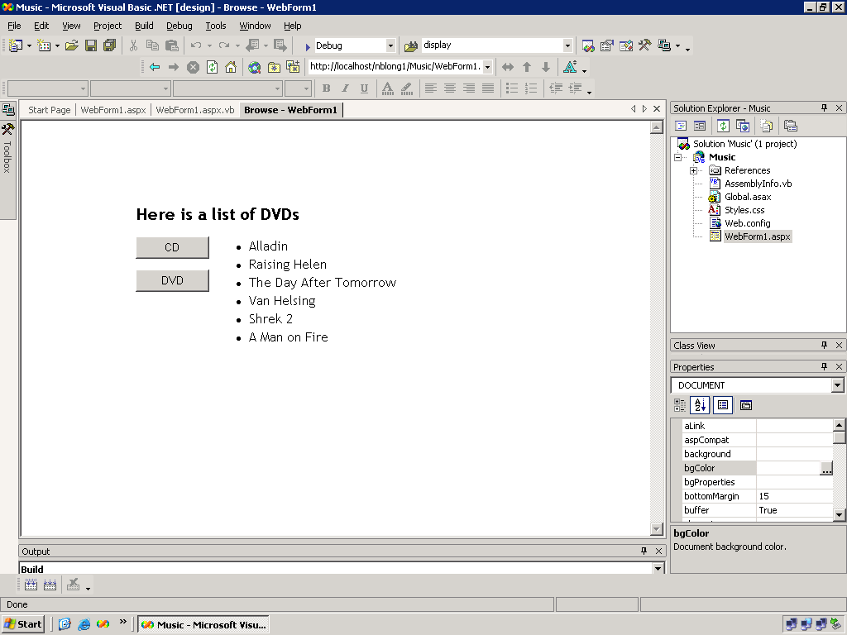

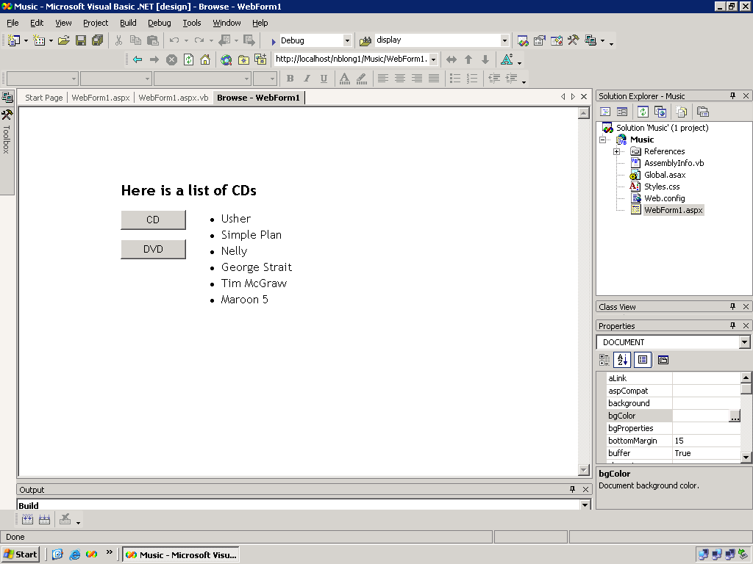

1. Click **WebSite**. Click **Copy Web Site.** Click **Connect.** Select **FTP Site**. Type in Server Name as *coit-ts2003.uncc.edu*. (makesure you enter it correctly) Unclick the **Anonymous Login** and input your username and password. Click **Open**. If windows show you block message, just **unblock** it. Select the folder **Music** which you have created today. Click **copy…to** button in the middle.
2. Launch a browser. In the Address text box enter:  
     
   http://coit-ts2003.uncc.edu/*<username>*/Music/WebForm1.aspx  
     
   Try the controls then close the browser.
3. Close Visual Studio and try to access your page from another browser on another machine. Take a look at the source code and see how it compares to the source code you from Visual Studio 2005. Take note of the source before clicking a button, and after each of the buttons have been clicked.