In this exercise you will create a webpage that has radio button controls.

1. Ensure you are connected to your **v:** drive (net use v: \\coit-ts2003.uncc.edu\yourid) or have your thumb drive in place.
2. Start **Visual Studio 2005**. In *Recent Projects* click Create: *Web Site…* to open the *New Web S*ite window.
3. In the New Web Site pane: In the Templates pane, click the **ASP.NET Web Site** icon. In the *Location:* line click on Browse… and select your v: drive (or your thumb drive letter is you have a thumb drive connected) and add \**Radio** to the end of the name, e.g. v:\Radio. If the Location already has WebSite1 at the end change that to **Radio**. Ensure *Language:* is set to Visual Basic. Click **OK** to create the solution, project, and default files. Note that an aspx file named Default.aspx along with a folder App_Data and another file web.config is created automatically for you. You can delete the Default.aspx file.
4. Right click the **v:\Radio** entry and click *New Folder*. Change the name of New Folder to **Radio**.
5. Right click the **Radio** folder and select Add New Item…. Select *Web Form*, and change *Name: Default.aspx* to **RadioForm.aspx**. Ensure *Language* is set to *Visual Basic*. Finally click ***Add***.
6. Ensure you are in the Design page vs. the Source page for **RadioForm.aspx**. From the *Toolbox* click on and drag *Label* into the design grid. Right-click somewhere in the page (but not on the new label) and select **Run As Server Control**.
   1. Next, click on the new label and in the Properties window, change the Label (ID) property to **lblTitle**. Delete the word “Label” from the Text property.
   2. Open the **Style Builder** by right clicking the label and select **Style….**  In the *Style Builder* select the *Position* tab and change *Position mode* to *Absolutely position* and set the following: *Top*: **200**, *Left:* **120**. Click **OK.**
7. Drag and drop a **Button** control from the Toolbox to the Design grid. In the Properties window, change the *(ID)* property to **btnSearch** and *Text* to **Search**. Open the **Style Builder** and change the position to *Absolutely position* *Top:* **160**, *Left:* **400**. Click **OK**.
8. Drag and drop four **Radio Button** controls from the Toolbox to the Design grid. They will be placed in a vertical line above the label from step .
   1. For each: in the Properties window, change the Label (ID) properties to **rb2300**, **rb3200**, **rb3300**, **rb4250**, respectively and the Text properties to **ITIS 2300**, **ITIS 3200**, **ITIS 3300**, **ITIS 4250**, respectively. The Checked property of each control should be **False**.
   2. So that these buttons will act as a group of buttons (e.g. only one may be selected), make sure all the buttons have the same GroupName.
   3. Open the Style Builder for each button. For each, right click each button, select Style… and set the position to Absolutely position with the *Top:* and *Left:* set to **40, 120**; then **80, 120**; then **120, 120**; and finally **160, 120** respectively.
9. Double-click the Search button. Type the following code, which determines which radio button is check between the Protected Sub… and End Sub lines on the RadioForm.aspx.vb page:.

If (rb2300.Checked = True) Then  
 lblTitle.Text = "Web-Based Application Development"  
 ElseIf (rb3200.Checked = True) Then  
 lblTitle.Text = "Introduction to Information Security and Privacy"  
 ElseIf (rb3300.Checked = True) Then  
 lblTitle.Text = "Software Requirements and Project Management"  
 ElseIf (rb4250.Checked = True) Then  
 lblTitle.Text = "Computer Forensics"  
 End If  
 rb2300.Checked = False  
 rb3200.Checked = False  
 rb3300.Checked = False  
 rb4250.Checked = False

1. Click the **RadioForm.aspx** tab to return to the Web Page. Click the **Save All** icon. Go to the Build menu and select **Build Solution**. Right-click the page and select **View in Browser**. The page should look like the ones shown below. Test the functionality by selected a radio button then clicking the Search button.
2. At this point you should notice that all or any of the buttons may be selected. For this application we want all four of the buttons to act as a group and have the selections be mutually exclusive. For each of the buttons: click each button control, then in *Properties* find *GroupName* and set to **Class**. Rebuild the solution and then view the page again. Test the buttons and now they should be mutually exclusive.

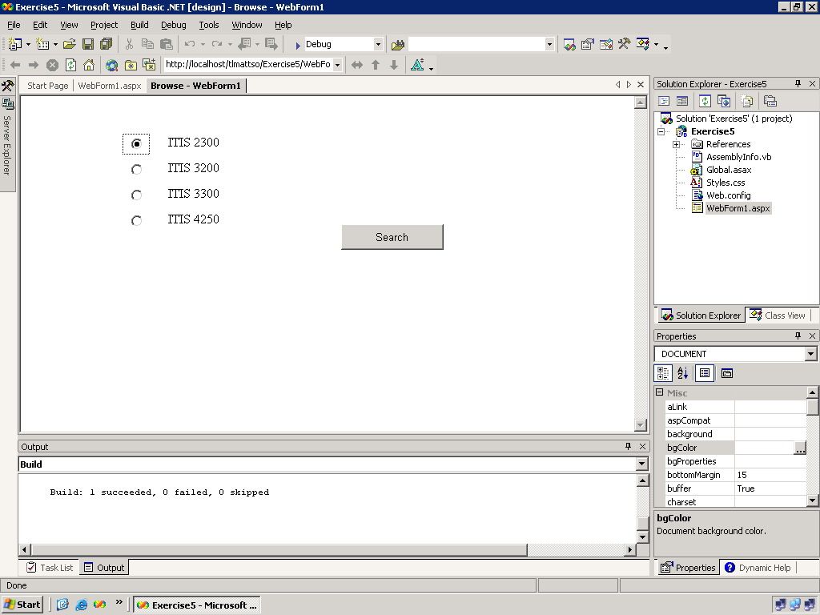

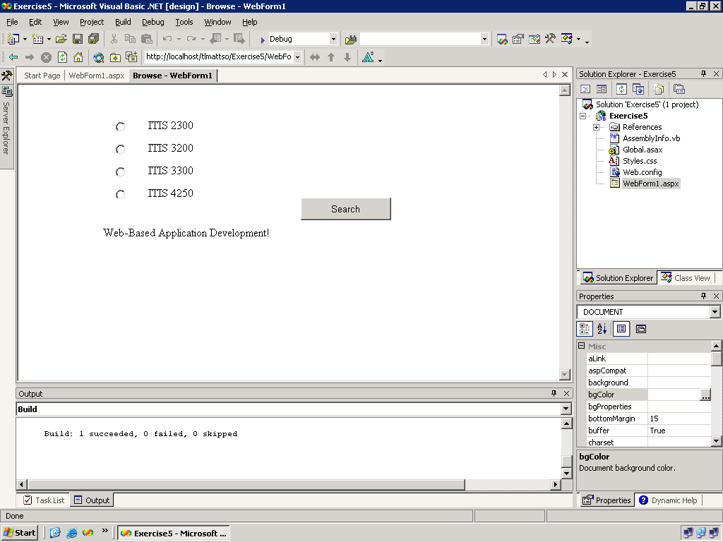

1. Publish the results to your id: Click **WebSite**. Click **Copy Web Site.** Click **Connect.** Select **FTP Site**. Type in Server Name as *coit-ts2003.uncc.edu*. (make sure you enter it correctly) Unclick the **Anonymous Login** and input your username and your SSN password. Click **Open**. If Windows shows you a block message, just **unblock** it. Select the folder **Radio** which you have created today. Click **copy…to** button in the middle.
2. Launch a browser. In the Address text box enter:  
   http://coit-ts2003.uncc.edu/*<username>*/Radio/RadioForm.aspx  
   Try the controls then close the browser.
3. Close Visual Studio and try to access your page from another browser on another machine.